**Detailed Project Report (DPR)**

**Concrete Compressive Strength Prediction**

|  |  |
| --- | --- |
| Written By | SHREYAS KHADYE  SUDHANSU GOUDA |
| Version | 1.0 |
| Date | 01/04/2023 |

**Document Change Control Record**

|  |  |  |  |
| --- | --- | --- | --- |
| **Version** | **Date** | **Author** | **Comments** |
|  |  |  |  |
|  |  |  |  |
|  |  |  |  |
|  |  |  |  |
|  |  |  |  |
|  |  |  |  |
|  |  |  |  |
|  |  |  |  |
|  |  |  |  |
|  |  |  |  |
|  |  |  |  |
|  |  |  |  |
|  |  |  |  |
|  |  |  |  |
|  |  |  |  |

Reviews

|  |  |  |  |
| --- | --- | --- | --- |
| **Version** | **Date** | **Reviewer** | **Comments** |
|  |  |  |  |

### Approval Status:

|  |  |  |  |  |
| --- | --- | --- | --- | --- |
| **Version** | **Review date** | **Reviewed By** | **Approved By** | **Comments** |
|  |  |  |  |  |

**Index**

|  |  |
| --- | --- |
| **Content.** | **Page No.** |
|  |  |
| 1. Introduction | 4 |
| 1.1 Abstract | 4 |
| 1.2 Machine Learning | 4 |
| 1.3 Problem Statement | 4 |
| 2. Architecture | 5 |
| 2.1 Data gathering | 5 |
| 2.2 Raw Data Validation | 5 |
| 2.3 Data Transformation | 6 |
| 2.4 New Feature Generation | 6 |
| 2.5 Data Preprocessing | 6 |
| 2.6 Model building | 6 |
| 2.7 Model saving | 6 |
| 2.8 Web app setup | 6 |
| 2.9 Git Hub | 6 |
| 2.10 Deployment | 7 |
| 3. Data set description | 7 |
| 4. Implementation and Results | 9 |
| 4.1 Implementation platform and language | 9 |
| 4.2 Observations | 9 |
| 4.3 Metrics for Data Modelling | 11 |
| 4.4 Prediction results | 12 |
| 5. Conclusion | 12 |
| 6. Future Scope | 12 |
| 7. Q & A | 13 |

# **1. Introduction**

# **1.1 Abstract**

Machine Learning is a category of algorithms that allows software applications to become more accurate in predicting outcomes without being explicitly programmed. The basic premise of machine learning is to build models and employ algorithms that can receive input data and use statistical analysis to predict an output while updating outputs as new data becomes available. These models can be applied in different areas and trained to match the expectations of management so that accurate steps can be taken to achieve the organization’s target. In this paper, the case of Concrete Compressive Strength Prediction, it has been discussed to predict the compressive strength of concrete for understanding the effects of different factors on the concrete. Taking various aspects of a dataset and the methodology followed for building a predictive model, results with high levels of accuracy are generated, and these observations can be employed to make decisions to improve decisions.

**1.2 Machine Learning**

The data available is increasing day by day and such a huge amount of unprocessed data is needed to be analyzed precisely, as it can give very informative and finely pure gradient results as per current standard requirements. It is not wrong to say as with the evolution of Artificial Intelligence (AI) over the past two decades, Machine Learning (ML) is also on a fast pace for its evolution. ML is an important mainstay of IT sector and with that, a rather central, albeit usually hidden, part of our life. As the technology progresses, the analysis and understanding of data to give good results will also increase as the data is very useful in current aspects.

In machine learning, one deals with both supervised and unsupervised types of tasks and generally a classification type problem accounts as a resource for knowledge discovery. It generates resources and employs regression to make precise predictions about future, the main emphasis being laid on making a system self-efficient, to be able to do computations and analysis to generate much accurate and precise results. By using statistic and probabilistic tools, data can be converted into knowledge. The statistical inferencing uses sampling distributions as a conceptual key.

ML can appear in many guises. In this paper, firstly, various applications of ML and the types of data they deal with are discussed. Next, the problem statement addressed through this work is stated in a formalized way.

## 1.3 Problem Statement

The quality of concrete is determined by its compressive strength, which is measured using a conventional crushing test on a concrete cylinder. The strength of the concrete is also a vital aspect in achieving the requisite longevity. It will take 28 days to test strength, which is a long period. So, what will we do now? We can save a lot of time and effort by using Data Science to estimate how much quantity of which raw material we need for acceptable compressive strength. The aim is to build a solution that should able to predict the compressive strength of the concrete.

**2. Architecture:**

Following workflow was followed during the entire project.

Process Flow

[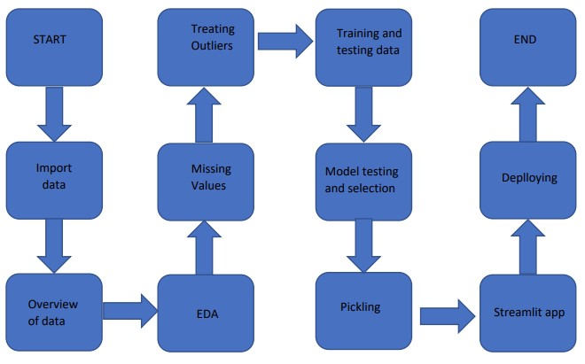](https://user-images.githubusercontent.com/123532199/228265721-f4f5c0d3-5437-4576-bdb5-c8e3d2889a7f.jpg)

**2.1 Data gathering:**

Data source: <https://www.kaggle.com/datasets/elikplim/concrete-compressive-strength-data-set>

**2.2 Raw Data Validation:**

After data is loaded, various types of validation are required before we proceed further for any operation. Validations like, checking for complete missing values in any columns, etc. These are required because The attributes which contains these are of no use. It will not play role in contributing the sales of an item from respective outlets.

Like if any attribute is having zero standard deviation, it means that’s all the values are same, its mean is zero. Which indicate that either the attribute increases or decreases that output will remain the same. Similarly, if any attribute is having full missing values, then there is no use of taking that attribute into an account for operation. It’s unnecessary increasing the chances of dimensionality curse.

**2.3 Data Transformation**

Before sending the data into the database, data transformation is required so that data are converted into such a form with which it can easily be inserted into the database. Here, the ‘blast_ furnance_slag ’ ,‘fly_ Ash’ and ‘superplasticizer’ attributes contain a vast amount of missing values. So, they have been replaced them with the respective mean values

**2.4 New Feature Generation**

We haven’t derived a new category.

**2.5 Data preprocessing**

In data pre-processing all the processes required before sending the data for model building are performed. Like, here ‘blast_ furnance_slag’ ,‘fly_ Ash’ and ‘superplasticizer’ the attributes are having some values equal to 0,no doubt both of these attributes are viable for prediction due to maximum entry being zero in the model they can’t contribute much. So they have been replaced with the respective mean values. We also detected some outliers with the help of bar chart and replaced them with the respective mean values.

**2.6 Model building:**

After doing all kinds of preprocessing operations mention above and performing model training and testing the accuracy we came to the conclusion that Lasso Regression have the highest accuracy with 93% accuracy.

**2.7 Model saving:**

Model is saved using the pickle library in ‘. pkl’ format.

**2.8 Web App Setup:**

After saving the model in .pkl file format we then create an app.py streamlit web app framework (Written in python) and then use requests to extract all the form selection selected by the user and then we predict the salary prediction by using the selected records by the user.

**2.9 Git Hub:**

The whole project directory will be pushed into the GitHub repository.

GitHub Project link:

https://github.com/ShreyasKhadye/Concrete-Compressive-Strength-Prediction

**2.10 Deployment:**

The cloud environment was set up and the project was deployed from GitHub into the Streamlit Sharing cloud platform.

WebApp link –

[https://shreyaskhadye-concrete-compressive-strength-predicti-app-l56p7u.streamlit.app/](%20https://shreyaskhadye-concrete-compressive-strength-predicti-app-l56p7u.streamlit.app/)

**3. Data set description:**

In this dataset there is data about cement, Blast Furnance Slag, ­Fly Ash, Water, Superplasticizer, Coarser Aggregate, Fine Aggregate, Age which gives us a variety of combinations of data. Using all the observations it is inferred what role certain properties of concrete play and how they affect the Compressive Strength of concrete. The dataset looks like as

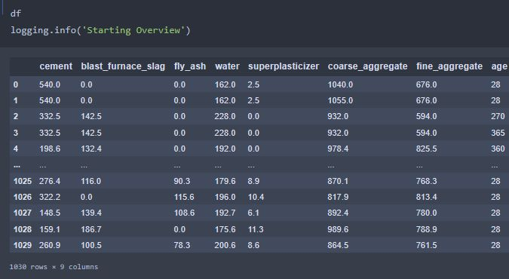

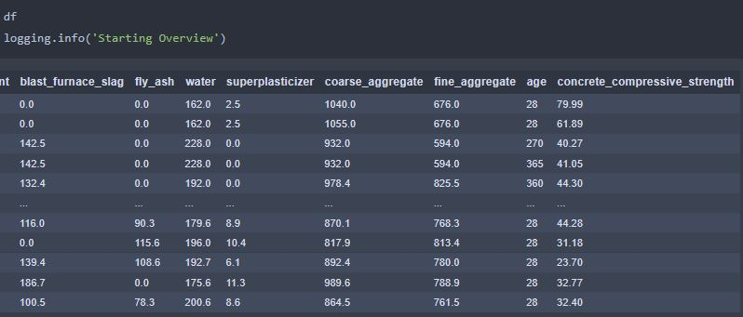

The data set consists of various data types from integer to float to object as shown in Fig.

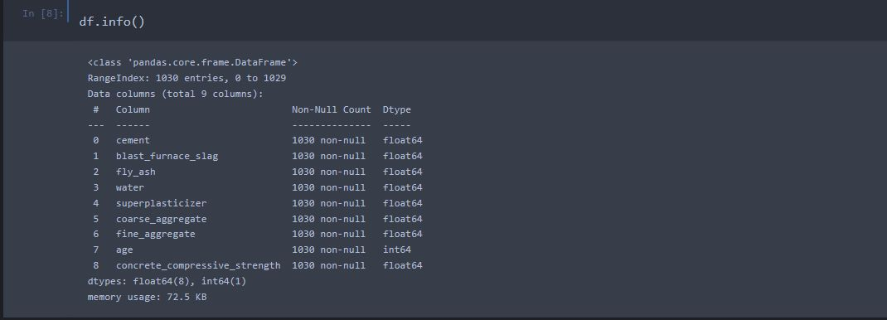

In the raw data, there can be various types of underlying patterns which also gives an in-depth knowledge about the subject of interest and provides insights into the problem. But caution should be observed with respect to data as it may contain null values, or redundant values, or various types of ambiguity, which also demands pre-processing of data.

The dataset should therefore be explored as much as possible.

Various factors important by statistical means like mean, standard deviation, median, count of values and maximum value, etc. are shown below for numerical attributes.

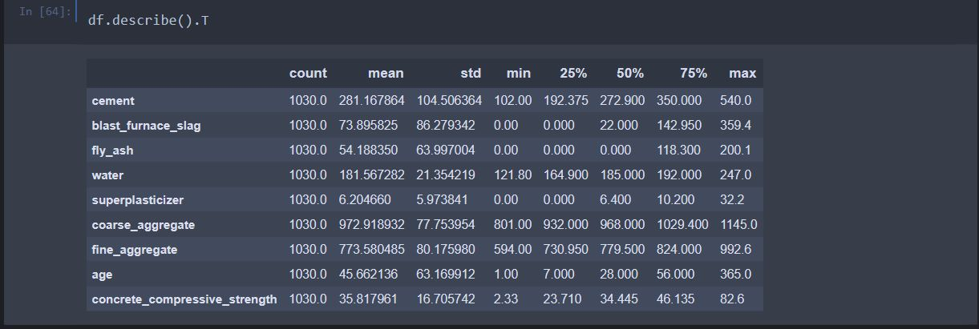Preprocessing of this dataset includes doing analysis on the independent variables like checking for null values in each column and then replacing or filling them with supported appropriate data types, so that analysis and model fitting is not hindered from its way to accuracy. Shown above are some of the representations obtained by using Pandas tools which tells about variable count for numerical columns and model values for categorical columns. Maximum and minimum values in numerical columns, along with their percentile values for median, plays an important factor in deciding which value to be chosen at priority for further exploration tasks and analysis. Data types of different columns are used further in label processing and one-hot encoding scheme during the model building.

# **4. Implementation and Results**

In this section, the programming language, libraries, implementation platform along with the data modeling and the observations and results obtained from it are discussed

## 4.1 Implementation Platform and Language

Python is a general purpose, interpreted-high level language used extensively nowadays for solving domain problems instead of dealing with complexities of a system. It is also termed as the ‘batteries included language’ for programming. It has various libraries used for scientific purposes and inquiries along with number of third-party libraries for making problem solving efficient.

In this work, the Python libraries of NumPy, for scientific computation, and Matplotlib, for 2D plotting have been used. Along with this, Pandas tool of Python has been employed for carrying out data analysis. Random forest classifier is used to solve tasks. As a development platform, Jupyter Notebook, which proves to work great due to its excellence in ‘literate programming’, where human friendly code is punctuated within code blocks, has been used.

## 4.2 Observations

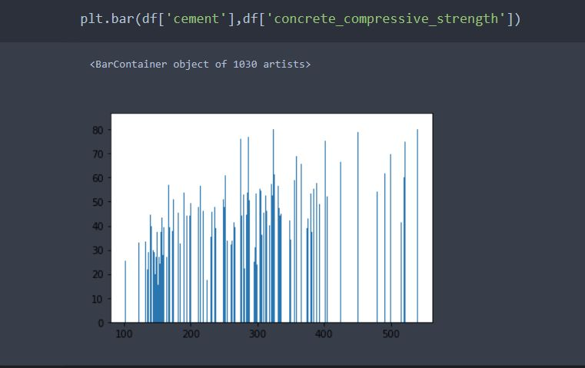

## 

## 

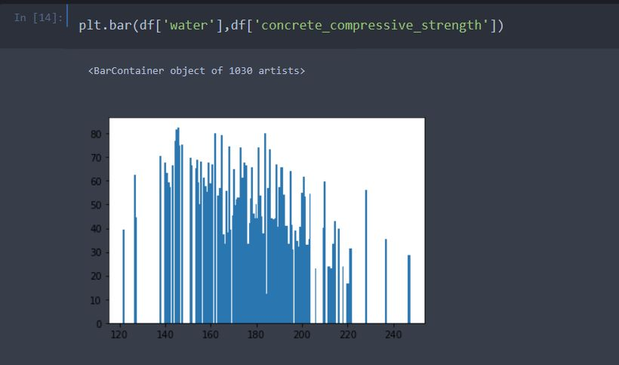

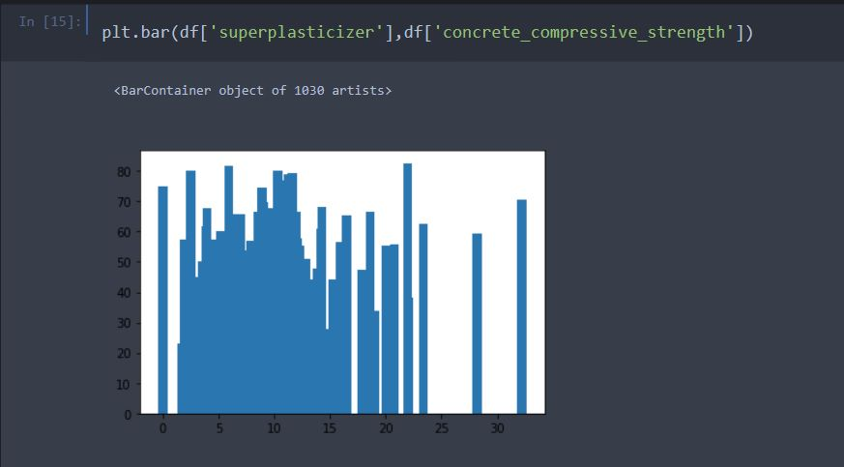

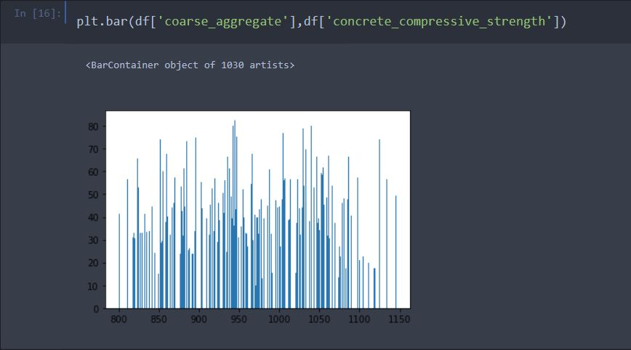

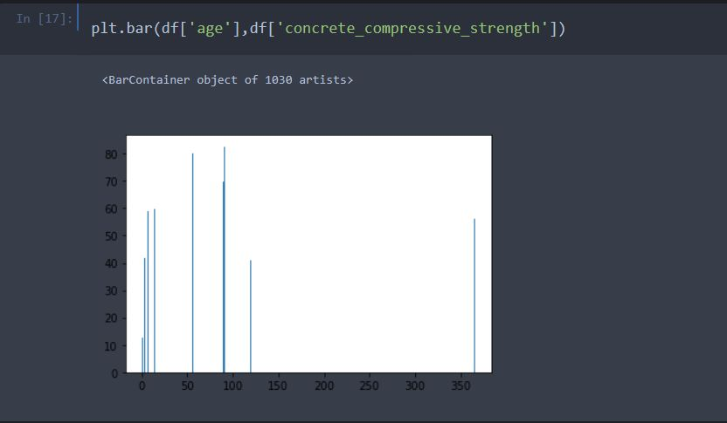

**We get the following insights from data visualizaton**

## fly_ash is Highly Dense From 75 to 200

## water is Highly Dense From 135 to 225

## superplasticizer is Highly dense from 0 to 24

## fine_aggregate is Highly dense from 600 to 900

## 4.3 Metrics for Data Modelling

For model selection we had used evaluation techniques which is score.

## 4.4 Prediction results

After doing all kinds of preprocessing operations mention above and performing scaling data is passed to Lasso Regression model . It was found that it performs best having the highest accuracy with 93% accuracy. So Lasso Regression performed well in this problem.

## 5. Conclusion

## In conclusion, concrete compressive strength prediction is a promising technology with a broad range of potential applications in infrastructure fields. Its ability to analyze patterns in concretedata can provide valuable insights and predictions that can enhance safety of the infrastructure. With continued advancements in the technology, its scope is likely to expand further, making it a valuable tool for construction industries. Overall, , concrete compressive strength prediction has the potential to contribute to a safer society.

## 6. Future Scope

The future scope of concrete compressive strength prediction is promising, as there are many advancements in technology and research that can help improve the accuracy and efficiency of predicting concrete strength. Here are a few potential areas of growth:

1. Artificial Intelligence and Machine Learning: With the increasing availability of data and computing power, machine learning algorithms can be trained to predict concrete compressive strength based on various parameters such as mix design, curing conditions, and environmental factors. This can lead to more accurate predictions and optimization of concrete strength.

2. Non-destructive Testing: Non-destructive testing techniques such as ultrasonic testing, impact-echo testing, and rebound hammer testing can provide valuable information about the strength and integrity of concrete structures without damaging them. These techniques can be used to validate the predictions of compressive strength and assess the health of existing structures.

3. Nanotechnology: Nanotechnology can be used to develop materials with enhanced strength and durability, which can improve the compressive strength of concrete. By incorporating nanoparticles into the concrete mix, researchers have been able to improve its mechanical properties, including compressive strength.

4. Sustainable Concrete: The development of sustainable concrete, which incorporates waste materials such as fly ash, slag, and recycled aggregates, can help reduce the environmental impact of concrete production. Researchers are working on predicting the compressive strength of sustainable concrete mixes to ensure that they meet the necessary standards for use in construction.

Overall, the future scope of concrete compressive strength prediction is vast, and continued research and innovation will help improve the accuracy and efficiency of predicting concrete strength, leading to better quality and more sustainable construction.

**7. Q & A:**

**Q1) What’s the source of data?**

Ans. The data for training is provided by the client from:

<https://www.kaggle.com/datasets/elikplim/concrete-compressive-strength-data-set>

**Q 2) What was the type of data?**

Ans. The data was consist of numerical values.

**Q 3) What’s the complete flow you followed in this Project?**

Ans. Refer the Architecture section for this.

**Q 4) What techniques were you using for data pre-processing?**

* + Removing unwanted attributes
  + Visualizing relation of independent variables with each other and output variables
  + Removing outliers
  + Cleaning data and imputing if null values are present.
  + Scaling the data

**Q 5) How training was done or what models were used?**

* Initially divided the data in training and validation set.
* Different algorithms were approached and Finalized algorithm is Laaso Regression.

**Q 6) How Prediction was done?**

Ans. The testing files are shared by the client. We pass its data to the best model which we have saved in pickle format and get the prediction.

**Q 7) Where the model was deployed?**

Ans. When the model is ready, we deploy it in Streamlit Sharing platform. This model is a web application where user can enter the data and these data gets extracted in the backend and user gets the prediction result.